How Does Natural Language Processing (NLP) Work?

- NLP models work by finding relationships between the constituent parts of language — for example, the letters, words, and sentences found in a text dataset.
- NLP architectures use various methods for data preprocessing, feature extraction, and modeling. Some of these processes are:
Data preprocessing: Before a model processes text for a specific task, the text often needs to be preprocessed to improve model performance or to turn words and characters into a format the model can understand. Data-centric AI is a growing movement that prioritizes data preprocessing. Various techniques may be used in this data preprocessing:
- Stemming and lemmatization: Stemming is an informal process of converting words to their base forms using heuristic rules. For example, “university,” “universities,” and “university’s” might all be mapped to the base univers. (One limitation in this approach is that “universe” may also be mapped to univers, even though universe and university don’t have a close semantic relationship.) Lemmatization is a more formal way to find roots by analyzing a word’s morphology using vocabulary from a dictionary. Stemming and lemmatization are provided by libraries like spaCy and NLTK.
- Sentence segmentation: breaks a large piece of text into linguistically meaningful sentence units. This is obvious in languages like English, where the end of a sentence is marked by a period, but it is still not trivial. A period can be used to mark an abbreviation as well as to terminate a sentence, and in this case, the period should be part of the abbreviation token itself. The process becomes even more complex in languages, such as ancient Chinese, that don’t have a delimiter that marks the end of a sentence.
- Stop word removal: aims to remove the most commonly occurring words that don’t add much information to the text. For example, “the,” “a,” “an,” and so on.
- Tokenization: splits text into individual words and word fragments. The result generally consists of a word index and tokenized text in which words may be represented as numerical tokens for use in various deep learning methods. A method that instructs language models to ignore unimportant tokens can improve efficiency.
- Feature extraction: Most conventional machine-learning techniques work on the features – generally numbers that describe a document in relation to the corpus that contains it – created by either Bag-of-Words, TF-IDF, or generic feature engineering such as document length, word polarity, and metadata (for instance, if the text has associated tags or scores). More recent techniques include Word2Vec, GLoVE, and learning the features during the training process of a neural network.
  - Bag-of-Words: Bag-of-Words counts the number of times each word or n-gram (combination of n words) appears in a document. For example, below, the Bag-of-Words model creates a numerical representation of the dataset based on how many of each word in the word_index occur in the document.
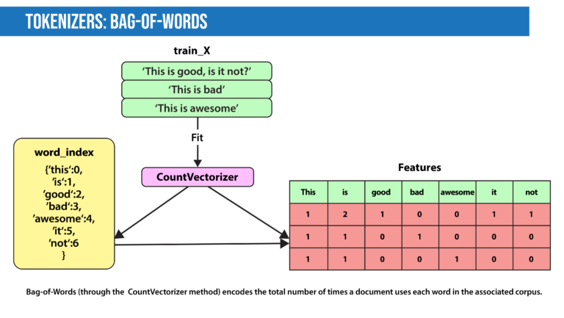
  - TF-IDF: In Bag-of-Words, we count the occurrence of each word or n-gram in a document. In contrast, with TF-IDF, we weight each word by its importance. To evaluate a word’s significance, we consider two things:
    - Term Frequency: How important is the word in the document?

TF(word in a document)= Number of occurrences of that word in document / Number of words in document

- Inverse Document Frequency: How important is the term in the whole corpus?
IDF(word in a corpus)=log(number of documents in the corpus / number of documents that include the word)
A word is important if it occurs many times in a document. But that creates a problem. Words like “a” and “the” appear often. And as such, their TF score will always be high. We resolve this issue by using Inverse Document Frequency, which is high if the word is rare and low if the word is common across the corpus. The TF-IDF score of a term is the product of TF and IDF.
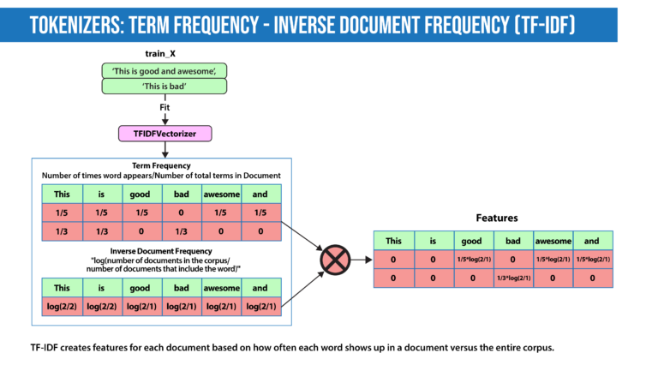

- Word2Vec: introduced in 2013, uses a vanilla neural network to learn high-dimensional word embeddings from raw text. It comes in two variations: Skip-Gram, in which we try to predict surrounding words given a target word, and Continuous Bag-of-Words (CBOW), which tries to predict the target word from surrounding words. After discarding the final layer after training, these models take a word as input and output a word embedding that can be used as an input to many NLP tasks. Embeddings from Word2Vec capture context. If particular words appear in similar contexts, their embeddings will be similar.
- GLoVE: is similar to Word2Vec as it also learns word embeddings, but it does so by using matrix factorization techniques rather than neural learning. The GLoVE model builds a matrix based on the global word-to-word co-occurrence counts
- Modeling: After data is preprocessed, it is fed into an NLP architecture that models the data to accomplish a variety of tasks.
  - Numerical features extracted by the techniques described above can be fed into various models depending on the task at hand. For example, for classification, the output from the TF-IDF vectorizer could be provided to logistic regression, naive Bayes, decision trees, or gradient boosted trees. Or, for named entity recognition, we can use hidden Markov models along with n-grams.
  - Deep neural networks typically work without using extracted features, although we can still use TF-IDF or Bag-of-Words features as an input.
  - Language Models: In very basic terms, the objective of a language model is to predict the next word when given a stream of input words. Probabilistic models that use Markov assumption are one example:
P(W_{n})=P(W_{n}|W_{n−1})
- Deep learning is also used to create such language models. Deep-learning models take as input a word embedding and, at each time state, return the probability distribution of the next word as the probability for every word in the dictionary. Pre-trained language models learn the structure of a particular language by processing a large corpus, such as Wikipedia. They can then be fine-tuned for a particular task. For instance, BERT has been fine-tuned for tasks ranging from fact-checking to writing headlines.

